# Soldering Process

Soldering is all about slowing down and making sure that you are soldering the correct components in the correct location with the correct orientation. Taking a few extra moments during the preparation stage will save you the time and hassle of fixing mistakes. Having a buddy to check your part placement prior to soldering is another good way to catch errors before they happen.

* **Get organized:** I always like to have a hardcopy of the schematic and layout and BOM before I start assembling a PCB. This arrangement helps me locate part designators, keep track of my components, and ensure placement of the right part in the right place. You can find these ancillary files posted on Canvas. Then, I spread out the parts and focus on finding the diodes, resistors, and ceramic capacitors – these are the parts I install first.

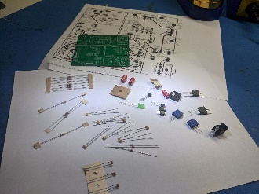

* **Select a part to install:** I would highly advise soldering in the lowest profile part first. By profile, I mean the height of the part off the board. In our case, this will be the resistors. I always install all the resistors of the same value at the same time. I use a pair of cutters to remove the resistors from the paper tape. Next, you will have to modify the shape of the leads to make installing the part in the board easier. Use a pair of needle nose pliers for this task. Bend the resistors as close to the body as possible.

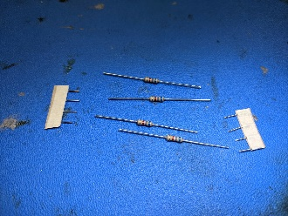

* **Form leads:** The metal wires extending out of a part is a lead. You will have to modify the shape of these leads to make installing the part in the board easier. Use a pair of needle nose pliers for this task. Bend the resistors as close to the resistor’s body as possible, be careful not to crack the body of the resistor.

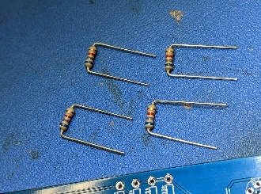 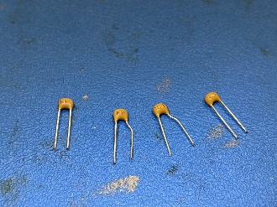

* **Stuff components:** This task sounds easy, but stuffing the board is the most important step because you are going to double check you are installing the correct component in the correct place! This instruction means reading the color codes on the resistor and checking it matches the part’s value silk screened on the PCB. Also, you should always align resistors so their tolerance bands are on the same side - *because you take pride in your work*. Once inserted, flip the board over and bend the leads outward so the resistor does not slip out of its hole during soldering.

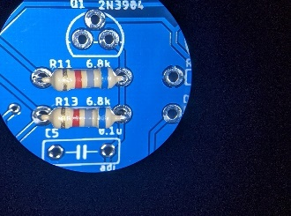 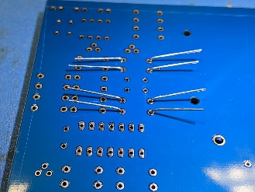

* **Solder components:** Apply the clean soldering tip to the junction of the component lead and the PCB. Feed in a bit of solder on the iron to make a liquid ball of hot solder. Wait 1-2 seconds for the ball to heat the lead and the PCB. Then, feed in about an ⅛” – ¼” of solder. After removing the solder, keep heating the joint for an additional 1-2 seconds. This heating will encourage the solder to seep well into the hole, creating a solid electrical and mechanical connection between the component lead and the PCB. One final note, **NEVER** hold a component in place with your fingers.

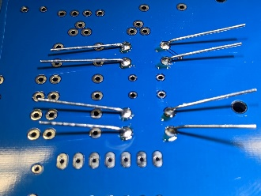

* **Trim leads:** This step is the most dangerous step because when trimmed, the leads will fly away with surprising speed, creating a hazard to anyone nearby who is not wearing eye protection. **Eye protection is mandatory while soldering**, either safety glasses or eyeglasses. Prescription glasses are fine as we work in a low-kinetic energy environment.

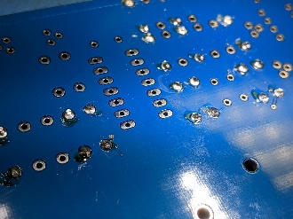

# Soldering Evaluation

The previous section focuses a lot on correct parts placement. One goal of this class is to improve the quality of the solder joints you make. Later in the term you will review a someone else’s soldering work. When we do this, we will use the Soldering and Component keys. Keep these in mind to self-assess your own work and stive to improve the quality of your work.

# Soldering Key <https://learn.adafruit.com/adafruit-guide-excellent-soldering/common-problems>

* P **P**erfect
* TM **T**oo **m**uch solder
* NE **N**ot **e**nough solder
* CJ **C**old **j**oint
* H Too much **h**eat

**Component Placement Key**

* P **P**erfect
* IP **I**ncorrect orientation of **p**olarized component
* IN **I**nconsistent orientation of **n**on-polarized component (resistor tolerance bands)
* L **L**ead not trimmed flush with board
* F Part not **f**lush with board or the part is not seated perpendicular to board

**Rubric**

Table 1 is an example soldering assessment rubric that you will fill out later in the term. Your first few soldering attempts will not be assessed because I want you to have some time to master the techniques. You will assess soldering by inspecting each soldered component in Table 1 and entering the quality of the solder connection in the “Solder” columns and the quality of the component in “Comp” columns. You can use multiple codes as needed.

Table : Example PCB evaluation rubric used later in the term. Fill in Solder, Comp columns. Grey cells are polarized comps.

|  |  |  |  |  |  |  |  |  |
| --- | --- | --- | --- | --- | --- | --- | --- | --- |
| Blue | Solder | Comp | Green | Solder | Comp | Red | Solder | Comp |
| PWR JACK |  |  | R10/100 |  |  | R1/33k |  |  |
| C7/100uF |  |  | D3/1N4148 |  |  | C4/60nF |  |  |
| C8/10nF |  |  | D4/1N4148 |  |  | C5/60nF |  |  |
| LED1 |  |  | POT/BIAS |  |  | R4/15k |  |  |
| R5/10k |  |  | C13/100uF |  |  | R6/3.3k |  |  |